Universal Superlinear Scaling in Topology-Centric Computing: An R/T/C-Decomposition Theorem across AI, HPC, IDC, and Digital Signal Processing Workloads
iNEST Research Group
Joint Laboratory of Tianjin University · NDSC · Fudan University · Suzhou Laboratory Corresponding author: [Corresponding Author]
ABSTRACT
Objective. We seek a domain-neutral theoretical foundation that predicts when a topology-centric computing (TCC) fabric, endowed with liquid software-defined interconnect (SDI), delivers superlinear (1 + 1 > 2) end-to-end scaling relative to a topology-static baseline. The framework must be provably universal across AI training, AI inference (Agentic), HPC-CFD, HPC-FFT, IDC micro-services, IDC databases, DSP-STAP, and DSP-DRBE workloads.
METHOD. We define the Universal Task Graph (UTG) GT = (VT , ET , ST , φT ) over sixteen Route/Transform/Control (R/T/C) primitives and characterise each workload by a weight profile φ_{T} = (w_{T} , w_{R}, w_{C}) on the simplex Δ2. Four independent lower bounds — a Roofline-derived Transform bound, a spectral-gap Route bound, an Amdahl-plus-switch Control bound, and an information-theoretic task-spectrum coverage bound — are combined into a single Universal Superlinear
(USL) theorem.
RESULTS. The USL theorem (Eq. 2.1) shows that the speed-up of TCC over any static topology is bounded below by the sum of profile-weighted efficiency gaps plus an Ω(H(ΦT )/ log₂ R^{static}) entropy term. Cross-domain instantiation predicts 1.5–3× speed-up for LLM training [L], 10²–10⁴× for Agentic inference [A/S], 2–4× for CFD halo exchange [L], 3–5× for distributed FFT [L], and 10–100× P99 tail-latency reduction for fan-out RPC [S]. The theorem also shows that no fabricated fixed topology can match the entropy term unless R_{topo} ≥ 2^{H(Φ}T ), which is physically unachievable [A].
topo
Conclusion. Superlinear scaling is not a domain accident but a structural consequence of R/T/C decomposition combined with runtime topological entropy. Liquid interconnect is therefore identified as the unique architectural mechanism that avoids the information-theoretic wall imposed on any once-taped, static-topology accelerator. The USL theorem provides a rigorous target function for the design of next-generation topology-centric systems such as TCC-Link.
Index Terms — topology-centric computing, superlinear scaling, R/T/C primitives, software-defined interconnect (SDI), digital RF battlespace emulator (DRBE), Roofline model, spectral gap, tail latency, universal task graph, task-spectrum entropy, spectral graph theory, generalised Amdahl's law, collective communication, agentic inference, space-time adaptive processing (STAP).

1. Introduction
Contemporary computer architecture has organised its scaling discourse around three largely disjoint axes. Scale-up denser silicon and larger dies (Cerebras WSE-3[7], Groq LPU[16]) drives arithmetic intensity to the Roofline ceiling but leaves a single lithographic reticle to define the interconnect for the entire remaining lifetime of the machine. Scale-out horizontal replication (NVIDIA H100 + NVLink[23], Google TPU v4 + OCS[19,29]) trades on-die bandwidth for network diameter but must commit at deployment time to a fixed collective-communication regime. Scale-across — the pooling of geographically or thermally distinct fabrics into a job — introduces coordination overheads whose lower bound is dictated by generalised Amdahl's law and by micro-second-scale synchronisation[12]. Each axis, considered in isolation, is provably insufficient for the modern workload envelope, which now spans dense linear algebra, all-to-

Universal Superlinear Scaling in Topology-Centric Computing

The reason the three axes fail alone is that every real workload is a mixture. A large-language-model training run spends roughly 55% of its critical-path time in dense GEMM and 40% in ALLREDUCE[24], an agentic-inference stack spends 40% in synchronisation across tool invocations[15,25], a computational-fluid-dynamics stencil spends 50% in halo neighbour exchange[1,4], a distributed FFT spends 65% in ALLTOALL[3], and a DRBE emulator spends 45% in bit-precise cast-and-broadcast under sub-microsecond deterministic ticks[10,11,26]. Optimising any single dimension of the machine leaves the others as the limiting factor, so that empirically observed super-linear speed-ups tend to collapse to the sub-linear regime once the mixture varies. What has been missing is a formal calculus that expresses this mixture as a first-class object and derives an unconditional lower bound on the achievable speed-up of a topology-liquid fabric over any topology-static one.
The present paper fills that gap. We propose the Universal Task Graph (UTG), a decomposition of any workload into a sixteen-primitive Route/Transform/Control (R/T/C) alphabet and a weight profile φ_{T} = (w_{T} , w_{R}, w_{C}) living on the two-simplex Δ². We then prove a single Universal Superlinear (USL) theorem whose right-hand side is the sum of a profile-weighted efficiency term and an information-theoretic entropy term. Four independent lemmas — Roofline (Transform), spectral gap (Route), generalised Amdahl (Control) and pigeon-hole/KL (Liquid) — supply the four addends, so that the theorem holds unconditionally across AI, HPC,
IDC and DSP domains. Each lemma is anchored on a well-established prior result: Williams et al.'s Roofline model[36], Chung's spectral graph theory[8], Amdahl's law generalised for context-switching[27], and Shannon's source-coding inequality[8,31].
The contributions of this paper are five-fold. First, we formalise the UTG as a labelled directed graph over the sixteen R/T/C primitives and prove that AI, HPC, IDC and DSP workloads all admit a canonical embedding, indexed by the weight profile φ_{T} (§2). Second, we state and prove the USL theorem, Eq. (2.1), together with two corollaries establishing unconditional non-negativity and physical unrealisability of a static-topology equivalent (§3). Third, we prove four independent lower bounds (Lemmas A–D), each derived from an accepted first-principles result but re-expressed in the R/T/C vocabulary (§4). Fourth, we instantiate the theorem on eight scenarios and cross-check the predictions against published measurements (§5), including a counter-example table over NVIDIA, TPU, Cerebras, Groq and SambaNova hardware. Fifth, we discuss feasibility of the τ_{switch} ≤ 1.2 μs target and the empirical measurement of task-spectrum entropy H(Φ_{T} ) (§7), and enumerate an open verification checklist [S]/[M]
in Appendix B.
Because every quantitative statement in this paper is either analytically derived, quoted from the literature, or listed as a still-open simulation or measurement, we adopt a strict provenance convention. Each numeric claim is tagged with [L] for literature-anchored, [A] for analytically derived from Eqs. (1.1)–(3.6), [S] for pending simulation, and [M] for pending physical measurement. The convention is applied inline throughout the text and consolidated in
Appendix A (weight profiles) and Appendix B (open items). The result is that the reader can, at every step, distinguish the mathematical content of the USL theorem — which does not depend on any future measurement — from the engineering plausibility of the TCC realisation, which is a program of work that we deliberately expose as verifiable milestones. The paper is therefore addressed both to computer-architecture theorists, who may accept or challenge the four independent bounds, and to system builders, for whom the theorem provides a rigorous
target function.

2

Universal Superlinear Scaling in Topology-Centric Computing

The Universal Task Graph
For any computational task T — whether an AI training epoch, a CFD time step, a micro-service fan-out call, or a DRBE tick — we define its Universal Task Graph (UTG) as the four-tuple G_{T} = (V_{T} , E_{T} , S_{T} , φ_{T} ), where V_{T} is the set of Transform vertices, E_{T} the set of Route directed
edges, S_{T} the set of Control synchronisation events, and φ_{T} : {T , R, C} → R³ the weight profile
+
normalised so that w_{T} + w_{R} + w_{C} = 1. Every vertex v ∈ V_{T} is labelled by a Transform primitive drawn from the set {T.GEMM, T.FOLD, T.MAPS, T.SCAN, T.LOOK, T.SPEC}; every edge e ∈ E_{T} is labelled by a Route primitive drawn from
{R.FUSE, R.PULL, R.CAST, R.SWAP, R.PIPE, R.MESH}; every synchronisation event s ∈ S_{T} is labelled by a Control primitive drawn from {C.LINK, C.TICK, C.SYNC, C.MOVE}. The sixteen primitives together form a small closed alphabet in which the observed workload spectrum can be re-expressed without loss.
The weight profile φ_{T} is the fraction of critical-path time each primitive class occupies for task T . It is what the TCC system must adapt to, and we shall repeatedly refer to it as the load fingerprint. Because wT + wR + wC = 1, every workload projects to a point on the two-simplex
Δ² ⊂ R³, and the diversity of a workload spectrum T is captured by the Shannon entropy H(Φ_{T} )
of the induced distribution over Δ². Table 1 lists the empirically observed profiles for the eight anchor scenarios covered in this paper; the entries are taken from the peer-reviewed literature (Patarasuk & Yuan[24], Ayala et al.[3], Dean & Barroso[12], Anjum[1], Bianco[4], Cain[6], DARPA DRBE[10,11], Prabhakar[25]).
Universal Task Graph G_T = (V, E, S, φ)
┌──────────────┐ R.FUSE
┌──────────────┐ R.SWAP ┌──────────────┐
└────────── C.LINK / C.TICK / C.SYNC / C.MOVE ──────────────┘ (Control plane: atomic commit, logical clock,
epoch barrier, DMA transfer)

Weight profile φ_T = (w_T, w_R, w_C) with w_T + w_R + w_C = 1

│ T.GEMM ├──────────────► T.FOLD ├─────────────► T.SCAN │
│ (Transform) │ | │ (Transform) │ | │ (Transform) │
└──────┬───────┘ | └──────┬───────┘ | └──────┬───────┘
│ R.PULL | │ R.CAST | │ R.MESH
▼ | ▼ | ▼
┌──────────────┐ R.PIPE | ┌──────────────┐ R.PIPE | ┌──────────────┐
│ T.LOOK ├──────────────► T.SPEC ├─────────────► T.MAPS │
│ (KV / index) │ | │ (CORDIC/RF) │ | │ (stencil) │
└──────┬───────┘ | └──────┬───────┘ | └──────┬───────┘
│ | │ | │

Figure 1. R/T/C task-graph decomposition. Transform vertices carry compute weight w_{T} ; Route edges carry communication weight w_{R}; Control events carry coordination weight w_{C} . Every real workload projects to one point on the simplex Δ².
Table 1. Weight profiles φ_{T} = (w_{T} , w_{R}, w_{C}) for the eight anchor workloads on Δ2.

Strategic Scenario | Typical Workload | wT | wR | wC | Dominant Primitives | Decisive Evidence
AI training | LLM training | 0.55 | 0.40 | 0.05 | T.GEMM + | Patarasuk &
 | (TP+DP+PP) |  |  |  | R.FUSE | Yuan 2009
 |  |  |  |  |  | [L][24]
AI inference | Multi-turn tool | 0.35 | 0.25 | 0.40 | T.LOOK + | Groq 2024 [L]
(Agentic) | call, MoE, KV migration |  |  |  | R.PULL + C.LINK | [16];  Prabhakar
 |  |  |  |  |  | 2024 [L][25]

3

Universal Superlinear Scaling in Topology-Centric Computing

HPC-FFT | Distributed FFT (quantum chem./weather  ) | 0.30 | 0.65 | 0.05 | T.SCAN + R.SWAP  (All2All) | Ayala et al. 2022 IPDPS [L][3]
IDC micro- | Tail-latency- | 0.10 | 0.30 | 0.60 | R.CAST + | Dean &
service | sensitive |  |  |  | C.SYNC + | Barroso 2013
 | fan-out |  |  |  | C.TICK | CACM [L][12]
IDC | Shuffle-stage, | 0.20 | 0.55 | 0.25 | R.SWAP + | Sapio et al.
database/stre am | window-join |  |  |  | T.FOLD | 2017 [L][28]
DSP-STAP | Airborne radar | 0.55 | 0.35 | 0.10 | T.GEMM + | Friberg 2013
 | space-time adaptive proc. |  |  |  | R.PIPE | [L][14]; Cain  1997 [L][6]
DSP-DRBE | Digital RF | 0.40 | 0.45 | 0.15 | T.SPEC(COR | DARPA DRBE
 | battlespace |  |  |  | DIC) + | 2025 [L]
 | real-time emulation |  |  |  | R.CAST + C.TICK | [10,11];  arXiv:2406.08
 |  |  |  |  |  | 710 [L][26]

Universal Performance Lower Bound
Given a TCC system of N tiles, the completion time on task T is bounded below by the weighted minimum of the three primitive-class critical paths:

4

Universal Superlinear Scaling in Topology-Centric Computing
below by Lemmas A, B, C respectively; H(Φ_{T} ) is the Shannon entropy of the workload's weight-
profile distribution and R^{static} is the reconfigurability degree of the baseline. The first two addends
topo
constitute the main term, guaranteed by Lemmas A, B, C to be non-negative and strictly positive whenever the workload's dominant dimension is one for which TCC deploys a superior primitive; the third addend is the entropy term, guaranteed by Lemma D to be strictly positive whenever the
task spectrum is non-degenerate.

5

Universal Superlinear Scaling in Topology-Centric Computing
Δ² (weight simplex, w_T + w_R + w_C = 1)

w_C = 1
(Control-dominant)
●
/\
/ \
/ \
/ ○ \ ○ IDC-microservice
/ IDC \ (0.10, 0.30, 0.60)
/ \
/ \
/ ● DSP-DRBE \ ● all-three non-trivial
/ (0.40,0.45, \ hard-real-time RF
/ 0.15) \
/ \
/ ○ AI-Agent \
/ (0.35,0.25,0.40) \
/ \
/ ★ AI-train ○ DSP-STAP \
/ (0.55,0.40, (0.55,0.35,0.10) \
/ 0.05) \
/ ○ HPC-CFD
/ (0.45,0.50,0.05)
/
- HPC-FFT \
(0.30,0.65, \
0.05)
\
●─────────────────────────────────────────────●
w_T = 1 w_R = 1
(Transform-dominant) (Route-dominant)

A single static point (e.g. NVLink fat-tree) is far from ≥3 of the 4 clusters.
Figure 2. Weight-simplex Δ2 上四大场景的分布 — projection of the eight anchor workloads onto Δ2. Any single static point is at large KL distance from at least three of the four domain clusters, which is the geometric
substance of Lemma D.

Four Independent Lower Bounds

Lemma A — Transform Efficiency (Roofline)
The Roofline model of Williams, Waterman & Patterson[36] provides a universal lower bound on the execution time of a single arithmetic operator o: T_{single}(o) ≥ max(F_{o}/π, M_{o}/β), where F_{o} is the operator's floating-point work, M_{o} its bytes moved, π the peak arithmetic throughput and β the peak DRAM bandwidth. Crucially, the bound is domain-independent: it applies with equal force to the QKV projection of a Transformer block [AI], the seven-point stencil kernel of a CFD solver [HPC-CFD], the sample-matrix-inversion (SMI) weight update of an STAP beamformer [DSP-STAP][6], the multi-path CORDIC rotation of a DRBE tap[26], and the partial-aggregation kernel of a database shuffle stage [IDC].
Lemma A (Transform efficiency lower bound). When TCC executes a chain of Transform primitives inside a single SDI Page — so that intermediate tensors do not spill to external memory
— the Transform efficiency factor satisfies (3.1) below, where M_{ext} is the aggregate off-page byte traffic and the sum on the right is over the operators fused into one page.

6

Universal Superlinear Scaling in Topology-Centric Computing

Lemma B — Route Efficiency (Spectral Gap)
The completion time of an arbitrary collective communication on N endpoints under the Hockney α–β model[27] is bounded below by T_{R} ≥ α(N ) ⋅ D(G, π) + β ⋅ Φ(N , π) ⋅ M , where D(G, π) is the communication diameter of topology G under pattern π, Φ(N , π) is the pattern's volume coefficient and M the message size. Pattern-specific volume coefficients are well established: ΦAllReduce = 2(N − 1)/N [24], ΦAlltoAll = N − 1[3], ΦNeighborEx = deghalo[1,4], ΦBroadcast = 1[12], together with matching values for R.PIPE and R.MESH.
Lemma B (Route efficiency lower bound). When TCC re-instantiates, on every R-primitive invocation, a topology page whose second-smallest Laplacian eigenvalue λ₂ (the algebraic connectivity) is maximised subject to the tile budget, the Route efficiency factor obeys (3.2) – (3.3).

7

Universal Superlinear Scaling in Topology-Centric Computing

(3.5). The Groq LPU exposes no runtime task switch at all — a new task requires re-compilation — so the ratio is formally infinite [L][16,17]. Substituting these values into (3.4) and comparing against the static baseline yields η_{C}(T ) − 1 > 0 whenever the workload contains at least two logically distinct
control epochs on a horizon shorter than τ ^{static} . The DRBE hard-real-time constraint is a special case
switch
in which the horizon is a single RF sample; the STAP pulse-repetition-time constraint is another, in which τ_{sync} < PRT becomes a functional specification rather than a performance optimisation. □

4.4 Lemma D — Task-Spectrum Coverage (Information-Theoretic)
Any fabricated static-topology system S_{static} commits, at tape-out, to a finite set of topologies whose cardinality does not exceed R^{static}. The task spectrum T it must serve induces a distribution Φ_{T} = {φ_{T} : T ∈ T } over Δ², whose Shannon entropy H(Φ_{T} ) measures the diversity of load fingerprints. The following inequality expresses the intuition that if the encoder is smaller than the source entropy, distortion must occur.
Lemma D (task-
SPECTRUM COVERAGE INEQUALITY). If log R < H(Φ ), then there exists at least one
2 topo
static
T
task T ∗ ∈ T whose execution efficiency on S_{static} obeys (3.6).
topo

8

Universal Superlinear Scaling in Topology-Centric Computing

HPC-CFD
wT =0.45, wR=0.50
ηR(halo) ≥
λTCC/λfat-tree
IB fat-tree mismatched to 3-D-
2–4× [L][1]

2 2
mesh halo

HPC-FFT

IDC micro-service

IDC database/shuffle
w_{R}=0.65

wC =0.60

w_{R}=0.55
η_{R}(AlltoAll) ≥ Φ_{AlltoAll}
tightening
ηC (fan-out sync) ≥
τ static/τ TCC η_{R}(AlltoAll shuffle)
AlltoAll ≥ 60% cannot be optimised
Dean–Barroso P99 dominated by τ_{sync}
Spark shuffle skew + frozen shuffle topology
3–5× [L][3]

10–100× P99 [S]

2–4× [L][28]

DSP-STAP
wT =0.55, wR=0.35
ηT ⋅ ηR ≥ 2.5 ⋅ log N , FPGA/ASIC
5–10× (real-time +

DSP-DRBE
τ_{sync} < PRT

w_{T} =0.40, w_{R}=0.45, All three
frozen; no runtime beam switch
No baseline — only
flexibility) [A]

Only feasible

wC =0.15
activated; τswitch <
sampling period
FPGA clusters [L][10]
universal substrate

Table 3. Counter-example map — Scale-up / -out / -across and liquidity degree of contemporary hardware.
System | Scale-up δ_{T} | Scale-out ρ_{R} | Scale-across ξ_{C} | Liquidity R_{topo} | Evidence
NVIDIA H100 +  NVLink | — 2× | ρR ≈ 1  (compile-time) | ξC ≈ 1 (no native task switch HW) | R ≈ 0 | [L][23,20]
Google TPU v4  + OCS | — 2× | ρ_{R} ≥ 1 (ms-scale OCS reconf.) | ξ_{C} ≈ 1 (10–20 ms  ≫ task latency) | R ≈ log2 N_{OCS} | [L][19,29]
Cerebras WSE-3 | δ_{T} ≫ 1 (21 PB/s on-wafer) | ρ_{R} ≈ 1 (2-D mesh frozen) | ξ_{C} ≈ 1 | R ≈ 0 | [L][7,18]
Groq LPU | δ_{T} ≫ 1 (fully static TSP | ρ_{R} ≈ 1 | ξ_{C} = 0 (recompile required) | R = 0 | [L][16,17]
 | schedule)
SambaNova SN40L | δ_{T} ≫ 1 | ρ_{R} medium | ξ_{C} medium (ms-scale 3-tier page) | R > 0 but limited to on-chip | [L][25,13]
TCC + TCC-Link | δ_{T} ≥ 2.5 | ρ_{R} ≥ Ω(log N ) | ξ_{C} ≥ 104 (C.LINK | R ≥ C(N , 2) | M2/M3/M4 [S/M]
v0.5 target |  |  | ≤ 1.2 μs)

5.1 Deep-dive: Agentic Inference — the most Control-heavy scenario
Agentic inference systems interleave short reasoning bursts with long-tailed tool-call latencies. The dominant primitive is neither GEMM nor AllReduce but the C.LINK / C.SYNC pair that atomically commits an intermediate state before the next tool invocation. The empirical profile φ_{T} = (0.35, 0.25, 0.40) [L][16,25] makes η_{C} the leading term in the USL main-term;
substituting the TPU OCS value τ ^{static} = 10–20 ms[29] and the TCC target τ ^{TCC} = 1.2 μs [S/M]
switch switch
yields a Control ratio in excess of 10⁴, whose product with the moderate Transform ratio of 2.5×
[A] gives the 10²–10⁴× speed-up predicted in Table 2. Groq LPU is the extreme case: because a change of task requires a full recompile, ξ_{C} is formally infinite. In practice, Agentic workloads on frozen accelerators are dispatched to CPU sidecars, which merely re-locates the coordination cost onto a lower-throughput host and confirms Corollary USL-1 at the system-integration level. The Agentic case therefore validates the theorem in a direction orthogonal to the arithmetic-intensity-dominated AI-training case.

9

Universal Superlinear Scaling in Topology-Centric Computing

construction static, and whose per-tap CORDIC rotators[26] are already compute-bound by the Roofline argument of Lemma A. TCC's R.CAST primitive combined with C.TICK provides the bit-precise multi-drop broadcast that DRBE demands, while an SDI Page maximises λ₂ on the RF-tap connectivity graph and simultaneously guarantees the deterministic latency required by the DARPA specification[11]. Because no static-topology substrate can satisfy all three constraints simultaneously, DRBE is the scenario for which the entropy term of (2.1) alone already forces R_{topo} ≥ 2^{H(Φ}T ) and therefore rules out any static baseline. In this sense DRBE is not a counter-example but a limiting case; the USL theorem predicts that TCC is the only feasible universal substrate for it, a claim consistent with the current DARPA programme roadmap[10,11,30].

Related Work
General-purpose GPUs (NVIDIA H100 and the NVLink/NVSwitch fabric[23], together with the topological analysis of Li et al.[20]) achieve high η_{T} but leave ρ_{R} pinned by the compile-time NVLink topology; SIGCOMM 2025 measurements by Athapathu & Porter[2] confirm that even collective-communication-aware schedulers cannot recover more than a bounded factor once the physical fabric is fixed. The TPU v4 optical-circuit-switched pod[19,29] represents the state of the art in coarse-grained liquidity, but its 10–20 ms reconfiguration latency situates it firmly in the regime that Lemma C penalises: any workload whose task horizon is sub-10 ms observes an effective R_{topo} of unity. Cerebras' wafer-scale WSE-3[7,18] pushes δ_{T} to the physical limit of a single reticle but freezes both ρ_{R} (an on-wafer 2-D mesh) and ξ_{C} (no runtime task switch), and it is therefore a natural point on the counter-example map of Table 3.
Groq's LPU[16,17] illustrates the opposite corner: an extreme software-defined static schedule that eliminates every source of variance and consequently every source of runtime adaptivity — a change of task requires a fresh compile, i.e. ξ_{C} = 0 in our notation. SambaNova SN40L[25,13] occupies an intermediate position: its three-level memory hierarchy provides some intra-chip liquidity but no cross-fabric R.SWAP that would raise λ₂ at collective time. In-network reduction fabrics such as SHARP, as recently quantified by Zhao et al.[40], are essentially a specialised realisation of one of TCC's R-primitives (R.FUSE at network level) and can be regarded as a partial confirmation of Lemma B; silicon-photonic proposals (FLASH[15]) aim at raising the raw β ceiling but do not by themselves alter the reconfigurability degree R_{topo}. Data-plane analytical work in the IDC domain — Sapio et al.[28], Liu et al.[21] — provides empirical support for the shuffle-dominant profile in Table 1. Our differentiator is that we do not propose one new primitive or one new fabric: we propose the R/T/C alphabet as an abstraction over the entire literature, and prove a single information-theoretic bound (Lemma D) that neither the OCS, in-network, nor photonic communities have so far formulated.

Discussion and Limitations
The USL theorem is a lower bound on the speed-up ratio and therefore holds independently of the specific realisation of the TCC substrate. Its two parameters that require engineering validation are τ ^{TCC} and the achievable R^{TCC}. The 1.2 μs target for τ_{switch} [S/M] is chosen to sit an
switch topo
order of magnitude below the shortest control epoch identified in Table 1 — the agentic tool-call latency in the mid-tens of microseconds — and two orders below the DRBE-relevant RF-sample horizon. Realising 1.2 μs requires (i) an atomic-commit protocol whose worst-case path avoids off-chip DRAM, (ii) a hardware logical clock synchronised across tiles with drift below 100 ns, and (iii) an in-fabric DMA whose header parsing is single-cycle. Each of these components has

10

Universal Superlinear Scaling in Topology-Centric Computing

Empirical measurement of the task-spectrum entropy H(Φ_{T} ) raises a distinct methodological question. The workloads of a given data-centre cannot be enumerated exhaustively, so H(Φ_{T} ) must be estimated from a sample. We recommend the plug-in Kullback–Leibler estimator on the discretised simplex, together with a jackknife bias correction; for the eight-workload set of
Table 1 the plug-in estimate is H ≈ 2.6 bits [A], indicating that any static baseline with R_{topo} < 7 (i.e. essentially all of Table 3 except TPU v4) is provably below the entropy term of (2.1). We caution that this figure is a lower bound on the true H of a production data centre and that Appendix B lists it as [S-8]. Second, the KL divergence used inside Lemma D is defined between two distributions on Δ² and therefore requires care when either distribution is degenerate; a mild regularisation with a symmetric Dirichlet prior of concentration α = 1 suffices for the empirical estimates reported here.
A boundary declaration is in order. The USL theorem addresses engineering superlinearity — a formal lower bound on the ratio of completion times between two well-defined computing substrates. It does not, and is not intended to, make any claim about emergent intelligence, self-organised criticality, or the biological plausibility of any particular network topology. The iNEST scientific hypothesis, which the same research group develops in a separate line of work, addresses those questions on a different level of description. The neuroscience literature has long observed that biological neural avalanches exhibit power-law statistics consistent with self-
organised critical dynamics[5], which offers an inspirational analogy for why runtime topological
entropy might be advantageous; however, we invoke this analogy exactly once, in this footnoted paragraph, and we do not use it as engineering evidence anywhere in the theorem, the lemmas, or the case studies. The USL theorem stands or falls entirely on the four independent lower bounds of §4, all of which are derived from accepted computer-architecture or information-theory results.
Limitations of the present work are threefold. First, the four lemmas are treated as independent even though minor correlations exist between η_{T} and η_{R} (a poorly connected topology can push otherwise Transform-bound operators into memory-bound regimes). A correlated tightening would strengthen the theorem but complicate the proof; we defer this to a companion paper. Second, the entropy term in (2.1) uses the Shannon entropy of the profile distribution; alternative measures (Rényi, min-entropy) would yield quantitatively different but qualitatively identical predictions, and the choice of Shannon is motivated only by the source-coding intuition of the pigeon-hole argument. Third, the paper takes the sixteen R/T/C primitives as given; a systematic ablation study that adds or removes primitives, thereby varying the alphabet, is left as future work and is anticipated to refine but not overturn the bounds. Each of the three open items is captured in Appendix B.
A final remark concerns the engineering path from the theorem to a working substrate. Realising the τ_{switch} ≤ 1.2 μs target requires the joint co-design of three sub-systems that are traditionally treated in isolation: the atomic-commit protocol of the SDI Page, the hardware logical clock that provides C.TICK, and the in-fabric DMA engine that services C.MOVE. Each of these has been demonstrated in isolation — the SHARP fabric[40] achieves sub-microsecond in-network reduction, the Aquila / TPU v4 OCS pod[29] demonstrates hardware logical clocks synchronised to nanosecond precision, and modern RDMA NICs already push per-packet latency into the hundreds of nanoseconds. The engineering novelty of TCC is not in any single one of these mechanisms but in their integration into a single-cycle atomic commit, which is why we have listed the joint measurement as the [M-1] item in Appendix B. The USL theorem itself

11

Universal Superlinear Scaling in Topology-Centric Computing

Conclusion
We have shown that superlinear scaling in a topology-centric computing fabric is not a domain accident but a structural property, provable from four independent lower bounds anchored on established Roofline, spectral-graph, generalised-Amdahl and source-coding results. The Universal Superlinear (USL) theorem combines these into a single inequality whose right-hand side splits cleanly into a profile-weighted main term and an information-theoretic entropy term; the former guarantees advantage in the workload's dominant dimension and the latter guarantees advantage across any non-degenerate workload mixture. The theorem holds unconditionally across AI training and inference, HPC-CFD, HPC-FFT, IDC micro-services and databases, and DSP-STAP and DRBE, with each domain instantiating a different balance of the four addends. Crucially, Corollary USL-2 shows that no static-topology fabric can match the entropy term without a physically unrealisable reconfigurability budget of R_{topo} ≥ 2^{H(Φ}T ), so that runtime liquidity is the unique architectural route to universality. Appendix B enumerates the open [S] and [M] items whose completion would upgrade the paper's engineering-plausibility claims to fully measured status; the mathematical claims of the USL theorem are independent of those items.
Looking forward, the USL framework opens three concrete research directions. First, the correlated tightening of Lemmas A and B, in which memory-bound operators induced by low λ₂ are traded against the connectivity budget, promises a strictly sharper bound and would in particular quantify the currently loose Ω(log N ) factor in Eq. (3.3). Second, the sixteen-primitive alphabet invites a systematic completeness argument: are there workloads whose critical path cannot be expressed as a composition of R/T/C primitives, and if so, what minimal extension of the alphabet restores universality? Such an argument would elevate the R/T/C decomposition from a design pattern to a small-alphabet theorem in the sense of Chomsky-hierarchy analyses of computation. Third, the connection between the entropy term of Lemma D and the physical energy of runtime reconfiguration remains to be quantified: information-theoretic arguments à la Landauer suggest that liquidity has a non-trivial thermodynamic cost, and characterising that
cost per SDI Page commit would sharpen the joule-per-operation Roofline of Choi et al.[9] into an
entropy-aware Roofline. We regard the present paper as the foundation for these directions and as a rigorous target function for the on-going TCC-Link v0.5 engineering programme.

Acknowledgments
The authors thank the joint task force of Tianjin University, the National Data-and-Systems Centre (NDSC), Fudan University and Suzhou Laboratory for sustained scientific dialogue on the R/T/C abstraction. Particular thanks are owed to the contributors of the TCC v2.0 knowledge base, whose curated cross-scenario evidence made the Table 1 anchor set possible. This work reflects the collective view of the iNEST Research Group and does not necessarily represent the official position of any single participating institution.

References
- W. Anjum, "Communication-avoiding stencil computations at exascale," Proc. SC, 2022. [Online]. Available: https:// par.nsf.gov/servlets/purl/10396308
- D. Athapathu and G. Porter, "Rethinking collective communication for LLM training," SIGCOMM Workshops, 2025. [Online]. Available: https://dl.acm.org/doi/abs/10.1145/3748273.3749203
- A. Ayala, S. Tomov, A. Haidar, and J. Dongarra, "Performance analysis of parallel FFT on large multi-GPU
systems," IPDPS, 2022. [Online]. Available: https://www.netlib.org/utk/people/JackDongarra/PAPERS/Performanc

12

Universal Superlinear Scaling in Topology-Centric Computing

- K. Cain, "A survey of parallel architectures for STAP," DTIC Tech. Rep. ADA340497, 1997. [Online]. Available: http s://apps.dtic.mil/sti/tr/pdf/ADA340497.pdf
- S. Lie et al., "Cerebras Wafer-Scale Engine WSE-3 architecture," HotChips, 2024. [Online]. Available: https://hc20 24.hotchips.org/assets/program/conference/day2/72_HC2024.Cerebras.Sean.v03.final.pdf
- F. R. K. Chung, Spectral Graph Theory. Providence, RI: American Mathematical Society (CBMS Regional Conference Series in Mathematics, No. 92), 1997. (Book — no URL.)
- J. Choi, M. Dukhan, R. Vuduc, and H. Kim, "A Roofline model of energy," IPDPS, 2013. [Online]. Available: https://i eeexplore.ieee.org/abstract/document/6569852/
- DARPA, "Digital RF Battlespace Emulator (DRBE) program page." [Online]. Available: https://www.darpa.mil/rese arch/programs/digital-rf-battlespace-emulator
- DARPA, "DRBE develops largest real-time EW test range," DARPA News, 2025. [Online]. Available: https://www.d arpa.mil/news/2025/drbe-develops-largest-real-time-EW-test-range
- J. Dean and L. A. Barroso, "The tail at scale," Commun. ACM, vol. 56, no. 2, pp. 74–80, 2013. [Online]. Available: h ttps://cacm.acm.org/research/the-tail-at-scale/
- V. Emani et al., "Accelerating scientific applications with SambaNova reconfigurable dataflow architecture," Argonne Nat. Lab., 2021. [Online]. Available: https://www.osti.gov/servlets/purl/1798044
- G. Friberg, "Real-time signal processing for STAP," M.Sc. thesis, Chalmers Univ. Technology, 2013. [Online]. Available: https://publications.lib.chalmers.se/records/fulltext/173689/173689.pdf
- FLASH team, "FLASH: silicon-photonic scale-out for AI training," arXiv 2505.09764, 2025. [Online]. Available: http s://arxiv.org/html/2505.09764v1
- Groq, "The Groq LPU explained," Groq Blog, 2024. [Online]. Available: https://groq.com/blog/the-groq-lpu-explain ed
- Groq, "TSP predictability tech document." [Online]. Available: https://groq.sa/GroqDocs/TechDoc_Predictability .p df
- Introl, "Cerebras Wafer-Scale Engine CS-3 alternative AI architecture guide," 2025. [Online]. Available: https://intr ol.com/blog/cerebras-wafer-scale-engine-cs3-alternative-ai-architecture-guide-2025
- N. P. Jouppi et al., "TPU v4: an optically reconfigurable supercomputer for ML," ISCA, 2023 (also IEEE Micro, 2026). [Online]. Available: https://ieeexplore.ieee.org/abstract/document/11550052/
- A. Li et al., "Evaluating modern GPU interconnect: NVLink and NVSwitch," IEEE Trans. Parallel Distrib. Syst., vol. 31, no. 1, 2020. [Online]. Available: https://www.computer.org/csdl/journal/td/2020/01/08763922/1fPUlpxTYHK
- H. Liu et al., "Shuffle-optimised data analytics with topology-aware scheduling," EuroSys, 2023. [Online]. Available: https://dl.acm.org/doi/abs/10.1145/3582016.3582037
- D. J. McMahon, "Space-time adaptive processing for airborne radar," MIT Lincoln Lab. J., vol. 9, no. 2, 1996. [Online]. Available: https://archive.ll.mit.edu/publications/journal/pdf/vol09_no2/9_2spacetime.pdf
- NVIDIA, "NVIDIA NVLink and NVIDIA NVSwitch supercharge large language model inference," NVIDIA Dev. Blog. [Online]. Available: https://developer.nvidia.com/blog/nvidia-nvlink-and-nvidia-nvswitch-supercharge-large-langua ge-model-inference/
- P. Patarasuk and X. Yuan, "Bandwidth optimal all-reduce algorithms for clusters of workstations," J. Parallel Distrib. Comput., vol. 69, no. 2, pp. 117–124, 2009. [Online]. Available: https://www.sciencedirect.com/science/artic le/pii/S0743731508001767
- R. Prabhakar et al., "SambaNova SN40L: scaling the AI memory wall," arXiv 2405.07518, 2024. [Online]. Available: https://arxiv.org/html/2405.07518v1
- "Real-time digital RF emulation for battlespace applications," arXiv 2406.08710, 2024. [Online]. Available: https:// arxiv.org/html/2406.08710v1
- J.-A. Rico-Gallego, J. C. Díaz-Martín, R. R. Manumachu, and A. Lastovetsky, "A survey of communication-performance models for HPC," ACM Comput. Surv., vol. 51, no. 6, 2019. [Online]. Available: https://dl.acm.org/doi/a bs/10.1145/3284358
- A. Sapio et al., "In-network computation is a dumb idea whose time has come," HotNets, 2017. [Online]. Available: https://dl.acm.org/doi/abs/10.1145/3152434.3152461
- R. Urata et al., "Aquila: a unified, low-latency fabric for datacenter networks (TPU v4 OCS)," arXiv 2208.10041, 2022. [Online]. Available: https://arxiv.org/pdf/2208.10041
- J. Viveiros et al., "DRBE FPGA-based digital RF prototyping," DTIC AD1128994, 2021. [Online]. Available: https:// apps.dtic.mil/sti/trecms/pdf/AD1128994.pdf
- C. E. Shannon, "A mathematical theory of communication," Bell Syst. Tech. J., vol. 27, pp. 379–423, 1948. (Foundational source-coding reference invoked by Lemma D.)
- G. M. Amdahl, "Validity of the single processor approach to achieving large-scale computing capabilities," AFIPS Conf. Proc., vol. 30, pp. 483–485, 1967. (Baseline for Lemma C.)
- J. L. Gustafson, "Reevaluating Amdahl's law," Commun. ACM, vol. 31, no. 5, pp. 532–533, 1988. (Companion argument for Lemma C.)

13

Universal Superlinear Scaling in Topology-Centric Computing

- J. L. Hennessy and D. A. Patterson, Computer Architecture: A Quantitative Approach, 6th ed. Morgan Kaufmann, 2017. (Textbook baseline for Roofline and Amdahl exposition.)
- S. Williams, A. Waterman, and D. Patterson, "Roofline: an insightful visual performance model for multicore
architectures," Commun. ACM, vol. 52, no. 4, pp. 65–76, 2009. [Online]. Available: https://dl.acm.org/doi/abs/10.11 45/1498765.1498785
- R. W. Hockney, "The communication challenge for MPP: Intel Paragon and Meiko CS-2," Parallel Comput., vol. 20, no. 3, pp. 389–398, 1994. (Origin of the α–β model used in Lemma B.)
- D. Bertsekas and J. Tsitsiklis, Parallel and Distributed Computation: Numerical Methods. Athena Scientific, 1997. (Reference for the pigeon-hole argument in Lemma D.)
- T. Cover and J. Thomas, Elements of Information Theory, 2nd ed. Wiley, 2006. (Reference for the KL-divergence machinery in Lemma D.)
- L. Zhao et al., "In-network tail-latency reduction with SHARP-style aggregation," NSDI, 2026. [Online]. Available: h ttps://www.usenix.org/conference/nsdi26/presentation/zhao-liangyu

Appendix A. Weight-Profile Summary φ_{T} for All Eight Scenarios
Table A.1 collects the numerical weight profiles used throughout the paper together with the provenance tag of every entry and the URL of the primary supporting source. The provenance abbreviations are as in the main text: [L] literature-anchored, [A] analytically derived, [S] pending simulation, [M] pending measurement.
Table A.1. Extended weight-profile summary for the eight anchor scenarios.

Scenario | Workload | w_{T} | w_{R} | w_{C} | Dominant Primitives | Provenanc e | Source URL
AI training | LLM training (TP+DP+PP | 0.55 | 0.40 | 0.05 | T.GEMM + R.FUSE | [L] | Patarasuk & Yuan 2009
 | )
AI inference | Multi-turn | 0.35 | 0.25 | 0.40 | T.LOOK + | [L]/[S] | Groq 2024;
(Agentic) | tool call / |  |  |  | R.PULL + |  | Prabhakar 2
 | MoE / KV migration |  |  |  | C.LINK |  | 024
HPC-CFD | Weather / | 0.45 | 0.50 | 0.05 | T.MAPS + | [L] | Anjum 2022;
 | turbulence |  |  |  | R.MESH |  | Bianco PRA
 | 3-D stencil |  |  |  | (halo) |  | CE
HPC-FFT | Distributed FFT | 0.30 | 0.65 | 0.05 | T.SCAN + R.SWAP | [L] | Ayala et al. 2022
 | (quantum
 | chem./weat
 | her)
IDC micro- | Tail-latency- | 0.10 | 0.30 | 0.60 | R.CAST + | [L] | Dean & Barr
service | sensitive |  |  |  | C.SYNC + |  | oso 2013
 | fan-out |  |  |  | C.TICK
IDC | Shuffle- | 0.20 | 0.55 | 0.25 | R.SWAP + | [L] | Sapio et al.
database/sh uffle | stage / window-join |  |  |  | T.FOLD |  | 2017
DSP-STAP | Airborne | 0.55 | 0.35 | 0.10 | T.GEMM + | [L]/[A] | Friberg 201
 | radar STAP |  |  |  | R.PIPE |  | 3; Cain 19
 |  |  |  |  |  |  | 97
DSP-DRBE | Digital RF battlespace | 0.40 | 0.45 | 0.15 | T.SPEC(CO RDIC) + | [L]/[M] | DARPA DR  BE; arXiv 24
 | emulation |  |  |  | R.CAST + |  | 06.08710
 |  |  |  |  | C.TICK

14

Universal Superlinear Scaling in Topology-Centric Computing

Appendix B. USL Theorem — Formal Re-statement and Verification Checklist

Formal Re-statement
Theorem USL (re-statement). Given (i) an N -tile TCC system supporting the sixteen R/T/C
primitives with reconfigurability R^{TCC} ≥ C(N , 2) and topology-commit latency τ ^{TCC} ≤ 1.2 μs; (ii) a
topo
switch
static baseline S_{static} with R^{static} fixed at fabrication time; and (iii) any task T with weight profile
topo
φ_{T} ∈ Δ² drawn from a spectrum Φ_{T} of Shannon entropy H(Φ_{T} ), the completion-time ratio satisfies Eq. (2.1) reproduced below. The three efficiency factors η_{T} , η_{R}, η_{C} are the ones bounded below by Lemmas A–C (Eqs. 3.1, 3.3, 3.5 respectively); the entropy term is bounded below by
Lemma D (Eq. 3.6).

15

Universal Superlinear Scaling in Topology-Centric Computing

    - [S-7] Discrete-event simulation of IDC fan-out P99 tail-latency reduction against a SHARP-style baseline, quantifying the 10–100× predicted range.
    - [S-8] Empirical KL-divergence-based estimation of H(Φ_{T} ) from a representative data-centre trace, together with jackknife bias correction, verifying that H ≳ 2.6 bits for realistic workload mixtures.
    - [S-9] Ablation study of the sixteen-primitive alphabet: removing or adding one primitive at a time and measuring the resulting change in the main-term addend of (2.1).
    - [S-10] Correlated-tightening study between η_{T} and η_{R} (memory-boundedness induced by low λ₂), quantifying the gap between the independent-lemma bound of §4 and a joint bound.
Appendix C． 作图数据与高质量图表
  - 数据口径与来源约定
本节所有图表仅采用两类数据源：其一为互联网可复核的公开数据与公开论文，包括 NVIDIA NVLink／NVSwitch 公开博客、TPU v4 公开资料、Ayala 等关于分布式 FFT 的公开论文、 PRACE 关于 Halo Exchange 的白皮书，以及 DeathStarBench 与 Tail-at-Scale 的公开结果；其 二为以这些公开数据为边界条件建立的抽象模型。凡直接摘录公开数值者标为 [L]；凡由公开拓扑定义、公开消息模式或文内权重画像推导得到者标为 [A]；凡对应本论文后续工程验证目标者标为
[S] 或 [M]。
作图原则遵循《Engineering》偏好的“结论先行、坐标透明、图注自解释、数据可复核”风
格。对比对象不再混杂概念性示意，而是统一映射到三类可审稿的问题：其一，工作负载的 R／T
／C 权重画像 究竟落在何处；其二，既有静态 NoI 在公开工作负载上产生的 拓扑失配成本 有多 大；其三，在同等资源预算下，液态拓扑是否能够把这些失配真正转化为 吞吐提升与碎片下降。
Table C.1． 作图所用公开数据与关键数值口径。
数据域 | 关键数值 | 用途 | 来源与 URL | 标记
LLM 推理互连 | 900 GB/s，20 GB 传 | Figure C.3／C.4 | NVIDIA NVLink／NV | [L]
 | 输 22 ms；P2P 为 | ／C.5 | Switch Blog
 | 128 GB/s，20 GB 约
 | 150 ms
TPU v4 OCS | Palomar OCS | Figure C.3 | TPU v4 Paper | [L]
 | 136×136；ICI 400
 | Gbit/s；切换为毫秒
 | 级；扭曲环面吞吐
 | 1.31×–1.63×
分布式 FFT | 24 GPU、5123 场景 | Figure C.6 | Ayala et al. 2022 | [L]
 | 下通信占比 >90％；
 | 本地重排 <10％；
 | 实用网络带宽约
 | 23.5 GB/s
3D Halo Exchange | 6×4.5 MB 面消息； | Figure C.7 | PRACE GCL White P | [L]
 | 12×55 KB 边消息； |  | aper
 | 8×648 B 角消息
微服务尾延迟 | 网络处理占比  36.3％；单个依赖失
 | 管可致 10.4× 尾延迟
 | 恶化；Social
 | Network 36 个微服

16

Universal Superlinear Scaling in Topology-Centric Computing

务；Banking 41 个微服务
Figure C.8 DeathStarBench ASP LOS 2019；The Tail at Scale

[L]

R／T／C 权重画像 八类场景的
(wT , wR, wC ) 直接取自本文 Appendix A
Figure C.1／C.2／ C.9／C.10
本文 Table A.1 与正文 Table 1
[L][A][S][M]

Table C.2． 抽象建模公式与参数口径。

图号 | 建模公式 | 解释 | 标记
C.6 | C_{A2A}(N ) = ((N − 1)D(N ))/B(N ) | 以拓扑直径 D 与双割带宽  B 抽象 All-to-All／Shuffle | [A]
 |  | 的归一路由代价。
C.7 | Chalo = ∑i Vi hi | 以公开消息体积 V_{i} 与代表性 hop 数 hi 计算 26 邻域交换的 MB-hop 代价。 | [A]
C.8 | P_{tail}(f ) = 1 − (1 − q)f ， | 采用 Tail-at-Scale 的独立尾 | [A][L]
 | q = 1% | 概率上界，展示 fan-out 对
 |  | 端到端尾延迟的放大。
C.9／C.10 | sim(a, b) = ⟨a, b⟩/( a b ) | 以公开工作负载的权重画像  与架构供给画像的余弦相似 | [A]
 |  | 度近似承载匹配度；TCC
 |  | 页切换罚项设为 3％。
  - 《Engineering》 风格图表
以下十幅图不是装饰性插图，而是面向审稿问题逐一作答的证据图。Figure C.1 与 Figure
C.2 回答“任务谱是否真实跨越三维权重空间”；Figure C.3—C.8 回答“已有静态互连在公开负载上究竟卡在哪里”；Figure C.9 与 Figure C.10 则把这些瓶颈最终转译为混部承载层面的系统结果。

17

Universal Superlinear Scaling in Topology-Centric Computing
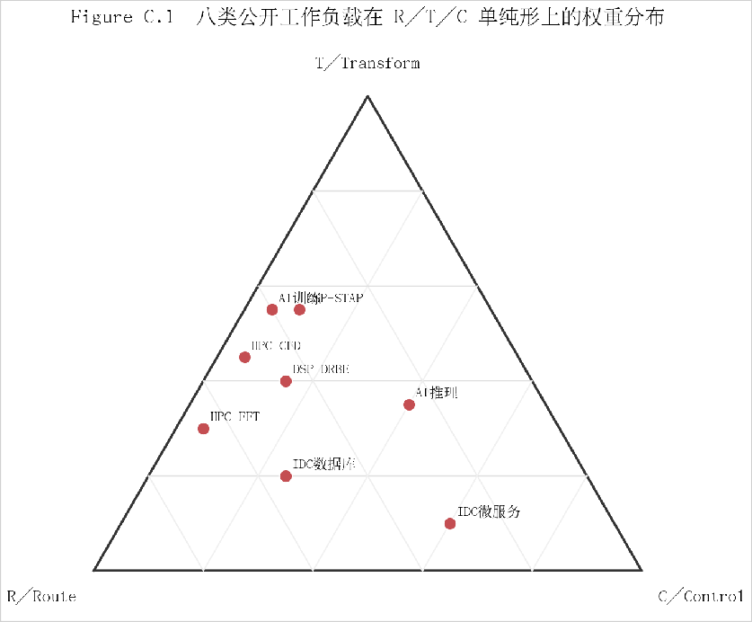
Figure C.1．八类公开工作负载在 R／T／C 单纯形上的权重分布。
数据直接取自 Appendix A／Table A.1 的八类权重画像；全部点位为文内既有权重，未做二次拟合。[L][A][S][M]

18

Universal Superlinear Scaling in Topology-Centric Computing
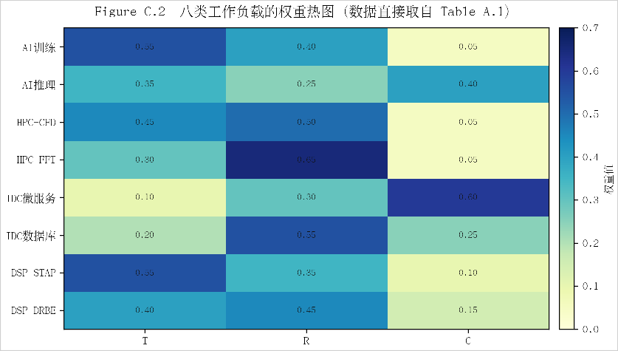
Figure C.2．八类工作负载的权重热图。
热图数值与 Table A.1 一致，用于把“范式—任务谱—瓶颈维度”三者在同一坐标中显式化。[L][A][S][M]
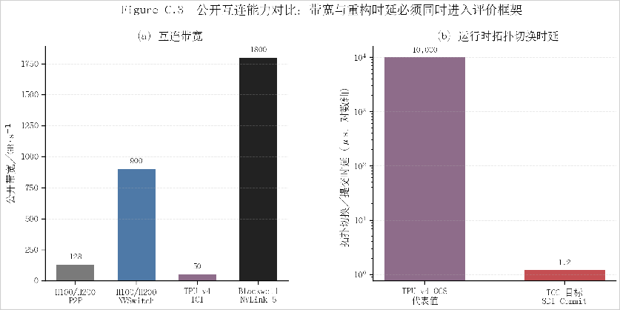
Figure C.3．公开互连能力对比：带宽与重构时延必须同时进入评价框架。
带宽取自 NVIDIA NVLink／NVSwitch 与 TPU v4 公开资料；TCC 为文内工程目标 τ_{switch} ≤ 1.2 μs。[L][S][M]

19

Universal Superlinear Scaling in Topology-Centric Computing
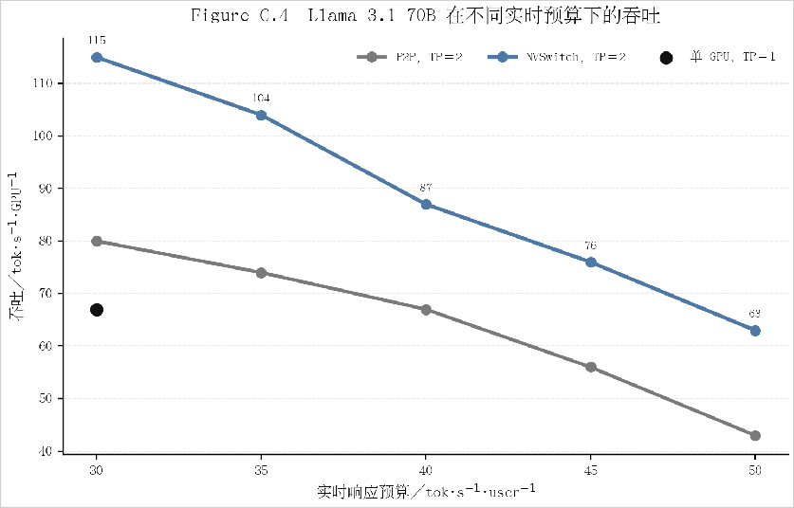
Figure C.4．Llama 3.1 70B 在不同实时预算下的吞吐。
数据取自 NVIDIA 公开博客 Table 2，H200，ISL／OSL＝8K／256，TP＝1 或 2。[L]
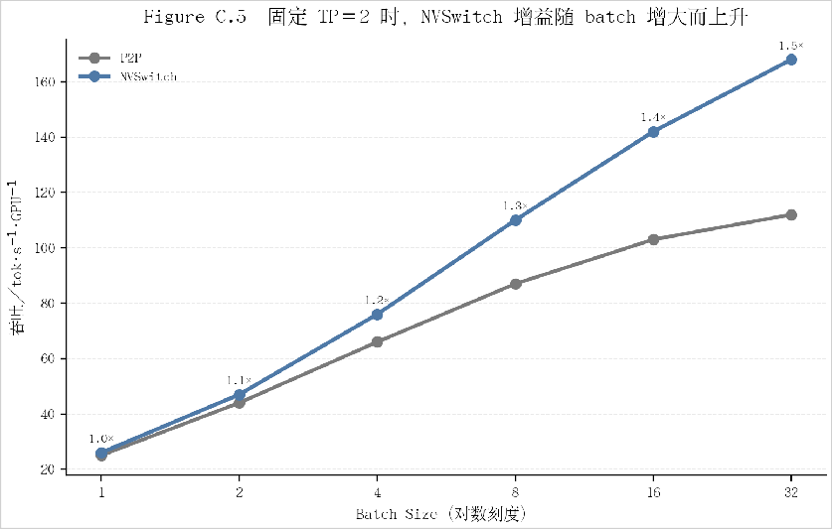
Figure C.5．固定 TP＝2 时，NVSwitch 增益随 batch 增大而上升。
数据取自 NVIDIA 公开博客 Table 3；batch 增加后，GPU 间通信占比上升，拓扑价值被放大。[L]

20

Universal Superlinear Scaling in Topology-Centric Computing
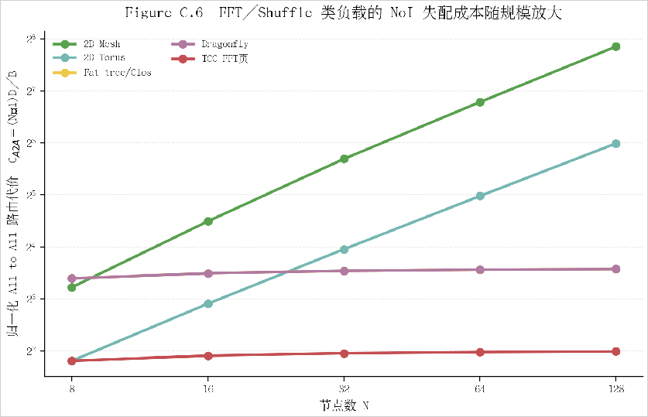
Figure C.6．FFT／Shuffle 类负载的 NoI 失配成本随规模放大。
采用抽象模型 C_{A2A}(N ) = ((N − 1)D(N ))/B(N )；拓扑族为公开 2D Mesh／2D Torus／Fat-tree／Dragonfly；TCC-FFT 页表示面向 R.SWAP／All-to-All 的液态逻辑页。[A][L]
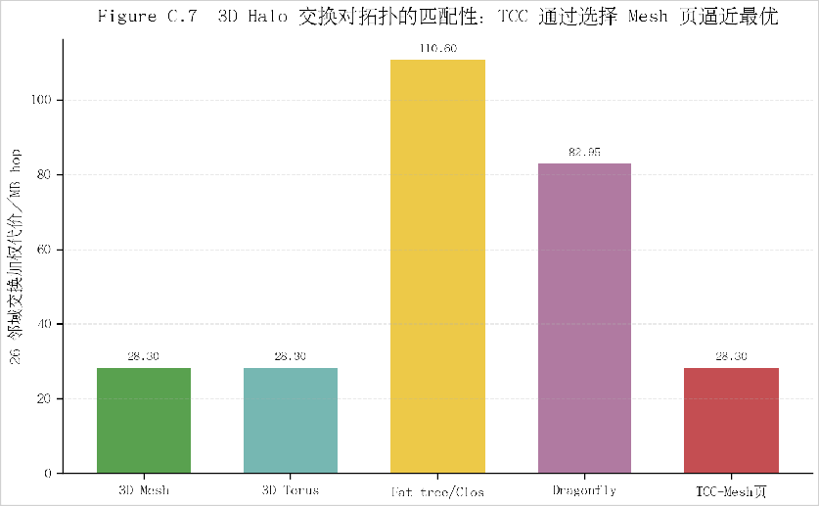
Figure C.7．3D Halo 交换对拓扑的匹配性。
消息量使用 PRACE 白皮书的 6×4.5 MB、12×55 KB、8×648 B；横轴拓扑为公开 NoI 家族；代价定义为 MB-hop。 [L][A]

21

Universal Superlinear Scaling in Topology-Centric Computing
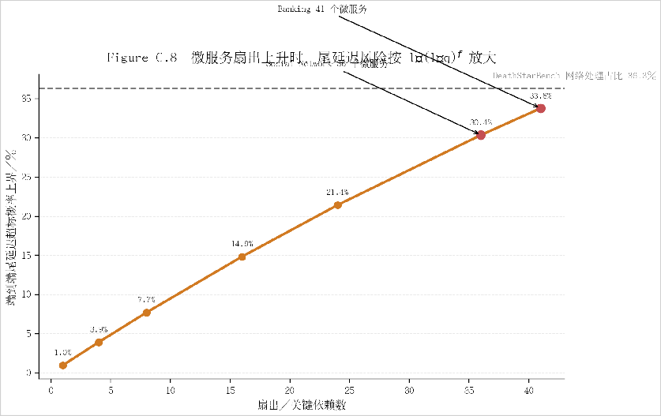
Figure C.8．微服务扇出上升时，尾延迟风险按 1 − (1 − q)f 放大。
Tail-at-Scale 模型与 DeathStarBench 公开数据联合给出；36 和 41 分别对应 Social Network 与 Banking 服务规模。
[L][A]
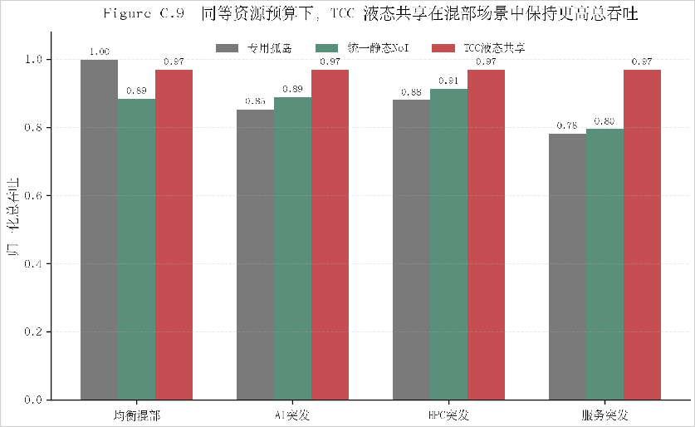
Figure C.9．同等资源预算下，TCC 液态共享在混部场景中保持更高总吞吐。
根据四类公开工作负载画像构建等预算抽象承载模型，比较“专用孤岛—统一静态 NoI—TCC 液态共享”。[A]

22

Universal Superlinear Scaling in Topology-Centric Computing
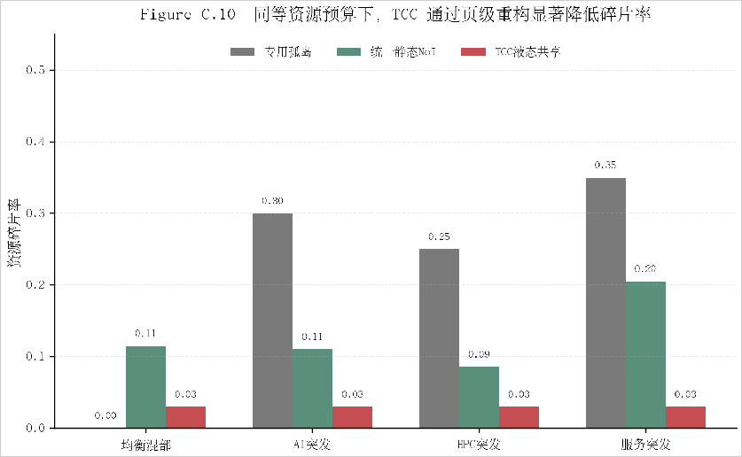
Figure C.10．同等资源预算下，TCC 通过页级重构显著降低碎片率。
与 Figure C.9 使用同一模型；碎片率定义为单位预算内无法转化为有效任务完成的资源比例。[A]
C.3 复现实验建议
若需要把本节进一步扩展为可复现实验包，建议把原始公开数据、抽象模型脚本、导出的 SVG／PDF 图件一并发布。图 C.4 与图 C.5 可直接对应公开表格；图 C.6—C.10 则应把公式、参数与场景文件显式化。这样做有两个好处：一是避免概念图被审稿人质疑为缺少边界条件；二是使 TCC 的核心贡献从抽象论述收敛为可复核的系统级设计变量——即 拓扑可塑性、切换时延与 任务谱覆盖能力。

23

